Dr. D .Y. Patil Polytechnic



**DR. D. Y. PATIL POLYTECHNIC**

**Nerul, Navi Mumbai**

Project Synopsis

On

**Face Recognition Attendance System**

(2017-2018)

**Submitted by**

|  |  |  |
| --- | --- | --- |
| Sr. No. | Name | Roll No. |
| 1 | Amisha Pupala | 48 |
| 2 | Pratiksha Kharatkar | 44 |
| 3 | Mokshada Godase | 34 |
| 4 | Pratiksha Batwal | 40 |

**Course/Branch : Computer Engineering**

**(Guide)**

**(H.O.D)**

**(Principal)**

Mr. Mayur Bhosale

Mr. Umesh Patil

Mr. S.G.Pathak

Dr. D .Y. Patil Polytechnic

**Abstract**

The face is the identity of a person. The methods to exploit this physical feature have seen a great change since the advent of image processing techniques. The accurate recognition of a person is the sole aim of a face recognition system and this identification maybe used for further processing. We propose a framework that takes the participation of students for classroom lecture. The proposed system framework takes the participation naturally utilizing face identification and recognition. This participation is recorded by utilizing a camera connected as a part of front of classroom that is continuously catching pictures of students, detect the faces in image and contrast the distinguished appearances and the database and mark the attendance. This paper describes the working of the face recognition system that will be deployed as an Automated Attendance System in a classroom environment.

|  |  |  |  |  |
| --- | --- | --- | --- | --- |
|  |  |  | Dr D .Y. Patil Polytechnic | |
|  |  | **Index** |  |  |
|  |  |  |  |  |
| Sr.no |  | Topics |  | Page no |
|  |  |  |  |  |
| 1 |  | Introduction |  | 1 |
|  |  |  |  |  |
| 2 |  | Literature Survey |  | 2 |
|  |  |  |  |  |
|  | 2.1 | Biometrics |  |  |
|  | 2.2 | Face recognition |  |  |
|  | 2.3 | Techniques for facial recognition |  |  |
|  | 2.4 | Current System |  |  |
| 3 |  | Requirement Analysis |  | 9 |
|  |  |  |  |  |
|  | 3.1 | Hardware requirements |  |  |
|  |  |  |  |  |
|  | 3.2 | Software requirements |  |  |
| 4. |  | Problem Definition |  | 10 |
| 5 |  | Designing |  | 12 |
|  |  |  |  |  |
|  | 5.1 | Flow chart |  |  |
|  |  |  |  |  |
|  | 5.2 | Data Flow Diagram |  | 13 |
|  |  |  |  |  |
|  | 5.3 | Block Diagram |  | 14 |
| 6 |  | Future Scope |  | 16 |
| 7 |  | Advantages and Disadvantages |  | 17 |
| 8 |  | Conclusion |  | 18 |
|  |  |  |  |  |
| 9 |  | Acknowledgement |  | 19 |
| 10 |  | Bibliography |  |  |
|  |  |  |  |  |

Dr. D .Y. Patil Polytechnic

1. **INTRODUCTION**

Face Recognition as it is often referred to as, analyses characteristics of a person's face image input through a camera. Facial recognition or face recognition as it is often referred to as, analyses characteristics of a person's face image input through a camera. Verification or identification can be accomplished from two feet away or more, without requiring the user to wait for long periods of time or do anything more than look at the camera. Maintaining the attendance is very important in all the institutes for checking the performance of employees. Every institute has its own method in this regard. Some are taking attendance manually using the old paper or file based approach and some have adopted methods of automatic attendance using some biometric techniques. But in these methods employees have to wait for long time in making a queue at time they enter the office. Biometric recognition has the potential to become an irreplaceable part of many identification systems used for evaluating the performance of those people working within the organization. Although biometric technologies are being applied in many fields it has not yet delivered its promise of guaranteeing automatic human recognition. Face recognition is a technique of biometric recognition. It is considered to be one of the most successful applications of image analysis and processing; that is the main reason behind the great attention it has been given in the past several years Many biometric systems are available but the key authentications are same is all the techniques. Every biometric system consists of enrolment process in which unique features of a person is stored in the database and then there are processes of identification and verification. These two processes compare the biometric feature of a person with previously stored template captured at the time of enrollment. Biometric templates can be of many types like Fingerprints, Eye Iris, Face, Hand Geometry, Signature, Gait and voice. Our system uses the face recognition approach for the automatic attendance of employees in the office room environment without employees’ intervention . Face recognition consists of two steps, in first step faces are detected in the image and then these detected faces are compared with the database for verification.

Dr . D .Y. Patil Polytechnic

**2. Literature survey**

**2.1 Biometrics:**

Biometrics is the automated recognition of individuals based on their behavioral or physiological characteristics .The physiological characteristics are related to the shape of the body. The most common example is fingerprint. Other examples include face recognition, hand geometry and iris recognition. The behavioral characteristics are related to the behavior of a person. Signature is one example of these characteristics which is still widely used today.

With the rapid development in the field of pattern recognition and its uses in different areas e.g. (signature recognition, facial recognition), arises the importance of the utilization of this technology in different areas in large organizations. This is mainly because these applications help the top-management take decisions that improve the performance and effectiveness of the organization. On the other hand, for an organization to be effective, it needs accurate and fast means of recording the performance of the people inside this organization. Biometric recognition has the potential to become an irreplaceable part of many identification systems used for evaluating the performance of those people working within the organization. Although biometric technologies are being applied in many fields it has not yet delivered its promise of guaranteeing automatic human recognition. This research is the first of its kind to attempt to provide an automated attendance system that recognizes students using face recognition technology through an image/video stream to record their attendance in lectures or sections and evaluating their performance accordingly.

**2.2 Facial Recognition**

Facial recognition (or face recognition) is a [biometric](http://searchsecurity.techtarget.com/definition/biometrics) method of identifying an individual by comparing [live capture](http://searchsecurity.techtarget.com/definition/live-capture) or digital image data with the stored record for that person. Most current facial recognition systems work with numeric codes called face prints. Such systems identify 80 nodal points on a human face. In this context, nodal points are end points used to measure variables of a person’s face, such as the length or width of the nose, the depth of the eye sockets and the shape of the cheekbones. These systems work by capturing data for nodal points on a digital image of an individual’s face and storing the resulting data as a face print. The face print can then be used as a basis for comparison with data captured from faces in an image or video.

Facial recognition systems based on face prints can quickly and accurately identify target individuals when the conditions are favorable. However, if the subject’s face is partially obscured or in profile rather than facing forward, or if the light is insufficient, the software is less reliable. Nevertheless, the technology is evolving quickly and there are several emerging approaches, such as [3D modeling](http://whatis.techtarget.com/definition/3D-modeling), that may overcome current problems with the systems.

**Techniques for feature extraction**

Face recognition compared to image processing is far more complex and there are several techniques in use today as listed below. Note: some methods are very old but the intuition behind them might come in handy.

1. **Graph matching:** In [Elastic Bunch Graph Matching](http://www.face-rec.org/algorithms/ebgm/wisfelkrue99-facerecognition-jainbook.pdf) a set of Gabor filters is used to construct an image graph of a face and face recognition is done by a straight forward matching of the graphs.
2. **Template matching:** [Face recognition using genetic algorithm based template matching](http://ieeexplore.ieee.org/xpl/login.jsp?arnumber=1413920&tp=&url=http%3A%2F%2Fieeexplore.ieee.org%2Fxpls%2Fabs_all.jsp%3Farnumber%3D1413920) can work remarkably well when implemented properly as earlier template based approaches were not practical due to severe variations between faces of the same person.
3. **Neural Networks:** [Face recognition using Neural networks](http://neuroph.sourceforge.net/tutorials/FaceRecognition/FaceRecognitionUsingNeuralNetwork.html) can range from full-face processing to face-landmark based processing. The full-face recognition approach involves having a large amount of the individual face images from a single person. The trick is to train the network to fire correctly when a particular face is presented using the usual backprop algorithm. In the landmark based approach part detector neural nets are trained on face landmarks such as right eye, left eye etc. and the final detection or recognition is based partly on the geometric relationship between the landmarks. You can also check [face detection](https://courses.cs.washington.edu/courses/cse577/05sp/papers/rowley.pdf)  using neural nets.
4. **Deep learning:** The area of deep learning involves learning richer, high-level abstract features from the training set before using a final classifier back-end. The convolutional nets are state-of-the-art in areas such as category-level object recognition systems including face recognition.
5. **3D based:** 3D techniques such those applied in Microsoft's Windows involves modeling a face in 3D from one or more face shots. Ideally it is required to obtain such a representation from one shot as done in Deep Face. The subsequent processing routines can then process the face from a canonical representation hence this helps the face recognizer system handle severe view point variations.

Dr. D .Y. Patil Polytechnic

**2.3 Current System**

Every time a lecture, section starts the lecturer or teaching .This is a lengthy process and takes a lot of time and effort, especially if it is a lecture with a huge number of students. It also causes a lot of disturbance and interruption when an exam is held. Moreover the attendance sheet is subjected to damage and loss while being passed on between different students or teaching staff. And when the number of students enrolled in a certain course is huge, the doctors tend to call a couple of student names at random which is not a fair student evaluation process either. Finally, these attendance records are used by the staff to monitor the students’ 3 attendance rates. This process could be easy and effective with a small number of students but on the other hand, dealing with the records of a large number of students often leads to human error.

Dr D .Y. Patil Polytechnic

**3. Requirement Analysis**

**3.1Hardware Requirements**

* Processing: 1.66 GHz Pentium Processor or Intel compatible processor.
* Memory: 2GB RAM
* 80 GB free Hard Disk space
* Web camera of Resolution: 512 by 512 pixels.

**3.2 Software**

* Visual Studio 2010(.Net framework)
* My SQL Server 2008

Dr D .Y. Patil Polytechnic

**6. Problem Definition**

The proposed system consists of a high resolution digital camera put on gate to monitor the classroom or office room. The data or images obtained by the camera are sent to a computer programmed system for further analysis. The obtained images are then compared with a set of reference images of each of the employees or students & mark the corresponding attendance. The system also provides for continuous monitoring of the classroom by an operator if needed. The camera module can be a wireless or wired system. In the standalone application , face was captured by the webcam cameras and the detected faces are stored in desktop webcam folder. The system designed is part of an in-house built learning management suite . It is constructed in many modules: Image capturing,− Face Detector and− Face recognizer.− The entire process is described in the pseudo code [Put the camera on the door. If it detects someone then capture the image and compare it with the stored database images If image matched then mark his/her attendance If not then ignore] The required infrastructure in classroom that camera should be positioned centrally in the front of the classroom. Using this setup, the camera is capable to capture frontal images from students. A different approach would be to use a camera at the entrance of the classroom, which would individually detect faces for everyone entering the classroom.

**Working of the system**

The device is composed of a digital camera that captures the pictures of the students or employees and sends it to the photo enrollment module. In enrollment module, snapshots are greater so that matching can be carried out without difficulty. After enrollment, the image comes in the face detection and reputation modules and then the attendance is marked in the database. At the time of enrollment, templates of face photograph of manual man or woman students are saved in the database. Right here all the faces are detected from the input image and the set of rules compares them one by using one with face database. If any face is recognized the attendance is marked in the data base from in which all of us can get entry and use it for specific purposes. Teachers come in the class and just press a button to begin the attendance manner and the system robotically gets the attendance without even the intentions of college students and teacher. In this manner a lot of time is saved and this is exceedingly securing process nobody can mark the attendance of different continuously to it upon and apprehends all the students in the school room. The gadget functions with the aid of projecting face image on to the feature space that spans the large variations among recognized face photographs .The large capabilities are regarded as “Eigen faces” ,because they are the Eigen vectors(essential elements) of the set of faces they do not necessarily correspond to the function such as eyes ,ears and noses .The projection operation characterize and character face by the weighted sum of the Eigen faces functions and so to understand a unique face it is necessary simplest to evaluate those weights to the ones people.

Dr D .Y. Patil Polytechnic

**7.Designing**

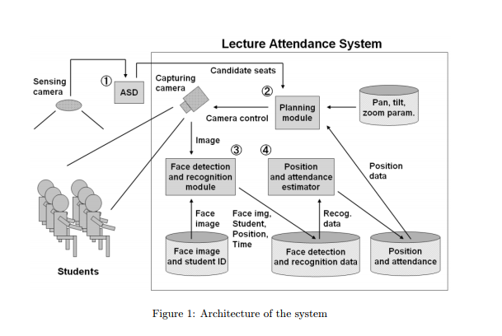

**7.1.Flow chart**

Start

Have you enrolled

Image capturing for identification or verification

Face detection

Image capturing to enrolled user’s face and do the extraction

Detect

e

tect

ed

Image

processing

Match up the captured image(extracted)with the database

Any

match

Identification or verification failed

Result display

End

extracted Stored the image into the database

YES

NO

YES

YES

NO

NO

Dr D .Y. Patil Polytechnic

* 1. **Data Flow Diagram**

**DFD Level 0**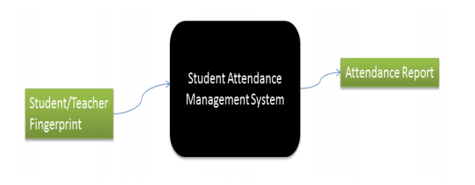

**DFD Level 1**

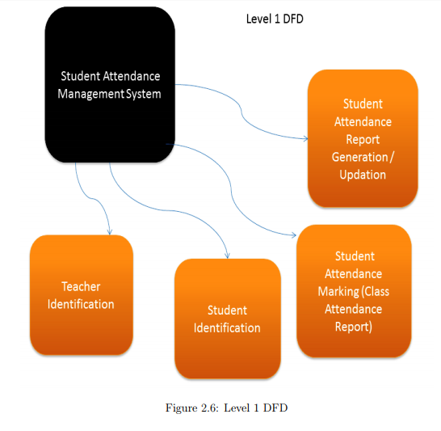

Dr D .Y. Patil Polytechnic

**Face Recognition Process**

**Block diagream:**

Web Cam

Face Detection

Face Image

Database

Feature Extraction

Eigen Faces

Nearest Neighbor

Classifier

Recognition

Database

Test Image

Dr D .Y. Patil Polytechnic

There are four steps in face recognition process:

1. **Acquiring a sample:** In a complete, full implemented biometric system, a sensor takes an observation. The sensor might be a camera and the observation is a snapshot picture. In our system, a sensor will be ignored, and a 2D face picture “observation” will supplied manually.
2. **Extracting Features:** For this step, the relevant data is extracted from the predefined captured sample. This is can be done by the use of software where many algorithms are available. The outcome of this step is a biometric template which is a reduced set of data that represents the unique features of the enrolled user's face.
3. **Comparison Templates:** This depends on the application at hand. For identification purposes, this step will be a comparison between a given picture for the subject and all the biometric templates stored on a database. For verification, the biometric template of the claimed identity will be retrieved (either from a database or a storage medium presented by the subject) and this will be compared to a given picture.
4. **Declaring a Match:** The face recognition system will return a candidate match list of potential matches. In this case, the intervention of a human operator will be required in order to select the best fit from the candidate list. An illustrative analogy is that of a walk-through metal detector, where if a person causes the 7 detector to beep, a human operator steps in and checks the person manually or with a hand-held detector.

Dr. D .Y. Patil Polytechnic

1. **Future scope**

The system we have developed has successfully able to accomplish the task of making the attendance in the classroom automatically and output obtained in an excel sheet as desired in real time. Another important aspect where we can work is towards creating an online data base of the attendance and its automatic updating, keeping in mind growing popularity of internet of things. The scope of the project is the system on which the software is installed, i.e. the project is developed as a desktop application, and it will work for a particular institute. But later on the project can be modified to operate it online. Again we can update the system in such a way that if the student is absent on a particular day then via mail the parents will automatically informed.

Dr D .Y. Patil Polytechnic

1. **Advantages and disadvantages**

**Advantages:**

* No More Time Fraud
* High Success Rate
* Automated Facial System
* Save time

**Disadvantages:**

* High Success Rate
* it still occupies significant amounts of disk space
* Angle of target face influences the recognition score profoundly

Dr D .Y. Patil Polytechnic

1. **Conclusion**

It can be concluded from the above dialogue that a dependable, secure ,rapid and an efficient system has been evolved changing a guide and an unreliable system .This process can be carried out for higher outcomes regarding the control of attendance .this system will keep time ,reduce the quantity of work the administration has to do and will update stationary material with digital apparatus .Every other application of this machine is that it is capable of marking the presence of personnel at any place of work and this attendance will be useful for calculating their month to month payment .

Dr. D .Y. Patil Polytechnic

1. **Acknowledge:**

Working on this project on “Face Detection and Recognition for Automatic Attendance System”

was a source of immense knowledge to us. We would like to express our sincere gratitude to Mr.

Mayur Bhosale sir for the guidance and valuable support thought out the course of this project

Work. Also thank you to our HOD Mr. Umesh Patil sir for his technical support and guidance.

We acknowledge with a deep sense of gratitude, the encouragement and inspiration received

from our faculty members and colleagues.

**10.Bibliography**

Sites refered for the project are as follows:

<https://mail.google.com/mail/u/0/#inbox/15e815608ba639d6?projector=1>

<https://www.researchgate.net/profile/Tetsuo_Shoji2/publication/241608617_Face_Recognition-based_Lecture_Attendance_System/links/54418ff00cf2a76a3cc82282/Face-Recognition-based-Lecture-Attendance-System.pdf>

https://www.quora.com/What-are-techniques-used-for-facial-recognition-and-image-processing

<https://www.ncbi.nlm.nih.gov/pubmed/8027706>

Books refered for the project are as follows :

* W. Zhao, R. Chellappa, P. J. Phillips, and A. Rosenfeld,“Face recognition: A literature survey,” ACM Computing Surveys, 2003, vol. 35, no. 4, pp. 399-458.
* Herbert Bay, Andreas Ess, TinneTuytelaars, and Luc Van Gool. Surf: Speeded up robust features. Computer Vision and Image Understanding (CVIU), 110(3):346–359.
* H.K.Ekenel and R.Stiefelhagen,Analysis of local appearance based face recognition: Effects of feature selection and feature normalization. In CVPR Biometrics Workshop, New York, USA, 2016

